

**Building a Database for an E-Commerce Website**

**Planning, Designing, and Managing Data for Online Shopping Platforms**



April 26, 2025

Database Systems **Semester Project  
  
Building a Database for an E-Commerce Website  
  
  
Submitted By:  
  
Alishba Pervaiz (Roll No: 242803)  
Andleeb Fatima (Roll No: 242710)**

**Submitted to:**

**Mam Kainat Nazir  
  
Department of Computer Science  
  
[Air university Islamabad]  
  
Spring 2025**

Database Systems Semester Project Phase 1:

# E-Commerce Website Database

## Introduction

In today's digital world, online shopping has become an essential part of our lives. To manage e-commerce activities efficiently, a strong database system is required. In this project, we will design and develop a database for an e-commerce website, which will store and manage information related to products, customers, orders, and payments. This project will help us understand the real-world application of databases and enhance our skills in database planning, designing, and management.

## Project Overview

### 1. Planning Phase

#### Task 1: Define Your Purpose and Audience

* **Purpose**:

The purpose of this project is to create a database system for an e-commerce platform. This platform will allow customers to browse different products, add items to their cart, place orders, and complete payments. The database will manage the records of customers, product details, orders, and payment transactions in an organized manner. Through this project, we aim to understand how data is stored, related, and retrieved in a commercial online environment.

* **Audience**:

The target audience for this database includes:  
- Customers who want to purchase products online.  
- Website administrators who need to manage product listings, customer details, and order processing.  
The database will facilitate smooth operations for both customers and administrators by providing fast and secure access to data.

#### Task 2: Sketch Your Database Layout

At this stage, the database layout is planned based on the core functionalities required by an e-commerce platform. The main entities considered for the database are:

**ENTITIES AND ATTRIBUTES:**

1. **User**

user_id (PK), email, password, role (Customers/Admins share this table with a role field)

1. **Customer**

customer_id (PK), user_id (FK), loyalty_points

1. **Product**

product_id (PK), name, price, stock, category_id (FK)

1. **Category**

category_id (PK), name, parent_category_id (FK)

1. **Order**

order_id (PK), customer_id (FK), status, total_amount

1. **OrderItem**

order_item_id (PK), order_id (FK), product_id (FK), quantity

1. **Payment**

payment_id (PK), order_id (FK), amount, status (success/failed)

1. **Cart**

cart_id (PK), customer_id (FK), created_at

1. **CartItem**

cart_item_id (PK), cart_id (FK), product_id (FK), quantity

1. **Review**

review_id (PK), product_id (FK), user_id (FK), rating, comment

1. **Address**

address_id (PK), user_id (FK), city, zip_code, is_default

1. **Coupon**

coupon_id (PK), code, discount, expiry_date

1. **Shipping**

shipping_id (PK), order_id (FK), tracking_number, status

1. **ProductImage**

image_id (PK), product_id (FK), url, is_primary

1. **Wishlist**

wishlist_id (PK), user_id (FK), product_id (FK)

**CARDINALITIES OR RELATIONSHIPS:**

1. **User → Customer** *(1:1)*  
   "is_a" (Inheritance - Every Customer is a User)
2. **User → Order** *(1:N)*  
   "places" (A user can place many orders)
3. **User → Address** *(1:N)*  
   "has" (A user can have multiple addresses)
4. **User → Review** *(1:N)*  
   "writes" (A user can write multiple reviews)
5. **User → Wishlist** *(1:N)*  
   "creates" (A user can have multiple wishlists)
6. **Order → OrderItem** *(1:N)*  
   "contains" (An order has multiple items)
7. **Order → Payment** *(1:1)*  
   "processed_via" (Every order has one payment)
8. **Order → Shipping** *(1:1)*  
   "dispatched_through" (One shipping record per order)
9. **Product → OrderItem** *(1:N)*  
   "sold_as" (A product can appear in many orders)
10. **Product → Review** *(1:N)*  
    "receives" (A product can have many reviews)
11. **Category Relationships**
    1. Category → Product (1:N) "contains"  
       *(One category can contain many products)*
    2. Category → Category (1:N) "parent_of"  
       *(Self-referential for hierarchy - a category can have many subcategories)*
12. **Cart Relationships**
    1. Customer → Cart (1:1) "owns"  
       *(Each customer has exactly one active cart)*
    2. Cart → CartItem (1:N) "includes"  
       *(A cart contains multiple items)*
13. **CartItem Relationships**
    1. CartItem → Product (N:1) "references"  
       *(Each cart item points to one product)*
14. **Coupon Relationships**
    1. Coupon → Order (1:N) "applies_to"  
       *(A coupon can be used on multiple orders)*
15. **ProductImage Relationships**
    * ProductImage → Product (N:1) "displays"  
      *(Multiple images can belong to one product)*

These entities are connected through relationships that will be clearly shown using an ERD (Entity-Relationship Diagram).

**ERD (Entity-Relationship Diagram):**

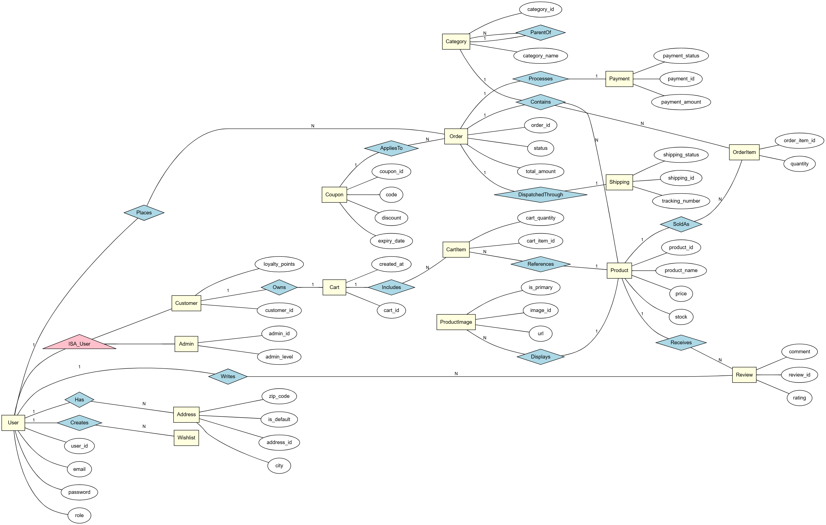

## Conclusion

The initial planning phase of the project has focused on defining the purpose and audience of the e-commerce database. It also outlines the basic structure that the database will follow. This planning will guide the next steps, including detailed ERD creation, database implementation, and testing to ensure efficient functioning of the online store's backend system.